Collaboration Corner

**Group B**

David Campbell

Ujjwal Pandey

Zhe Qian

# Actor Goal List for 'Collaboration Corner'

|  |  |  |  |  |  |
| --- | --- | --- | --- | --- | --- |
| Actor | Task-level Goal | Priority |  | Assigned To |  |
| Guest | Browse public projects. | 2 |  | David |  |
| Guest | Download public projects. | 5 |  | David |  |
| Guest | Register an account. | 1 |  | David |  |
| Registered User | Log in/out | 1 |  | David |  |
| Registered User | Browse around. | 2 |  | Zhe |  |
| Registered User | Download materials that they have access to. | 5 |  | Zhe |  |
| Registered User | Create a project. | 3 |  | David |  |
| Registered User | Delete a project | 3 |  | David |  |
| Registered User | Rate projects. | 6 |  | Zhe |  |
| Registered User | Comment projects | 6 |  | Zhe |  |
| Registered User | View projects | 6 |  | David |  |
| Registered User | Manage/access personal profile | 4 |  | David |  |
| Registered User | Accept/reject project invitation | 5 |  | Zhe |  |
| ~~Registered User~~ | ~~Report license violation project~~ |  |  |  |  |
| Project Manager | Control access to the project | 7 |  | Zhe |  |
| ~~Project Manager~~ | ~~View all works in the project~~ | 7 |  |  |  |
| Project Manager | Delete a project | 8 |  | David |  |
| Project Manager | Add/remove member in the project | 7 |  | Zhe |  |
| Project Manager | Manage project profile | 9 |  | David |  |
| ~~Project Manager~~ | ~~Merge sub-project~~ | 8 |  |  |  |
| Project Member | Modify project | 7 |  | Zhe |  |
| Registered User | Request join a project | 7 |  | Zhe |  |
| Web administrator | Review/moderate project/member/users | 1 |  | Zhe |  |
| Web administrator | Control visibility of content | 1 |  | Zhe |  |
| Web administrator | Edit improper info | 1 |  |  |  |

# Use Case Briefs

|  |  |  |
| --- | --- | --- |
| Actor | Task-level Goal | Brief |
| Guest | Browse public projects. | Let unregistered user browsing web content |
| Guest | Download anything which is free licensed. | Let unregistered user download free project etc. |
| Guest | Register an account. | To become a registered user |
| Registered User | Log in/out | As a registered user to log in the account |
| Registered User | Browse around. | Registered user will have more access to browsing project |
| Registered User | Download materials that they have access to. | Registered user will have more access to download project etc. |
| Registered User | Create/delete a project. | To create or delete a project, once a registered user created a project then this user will become the project manager. Once the project is deleted all the data in the project will be gone |
| Registered User | Rate/ comment/view projects. | To let the registered user rate or put comment under a project. |
| Registered User | Manage/access personal profile | Manage personal information such as name, profile avatar, etc.. |
| Registered User | Accept/reject project invitation | Registered user can accepts or rejects project manager’s invitation. |
| Project Manager | Control access to the project | Add or remove material in the project |
| Project Manager | View all works in the project | Project manager can view all the member’s work |
| Project Manager | Delete a project | Project manager delete a project will delete all the data in the project |
| Project Manager | Add/remove member in the project | Project manager can invite or remove a member who is a registered user |
| Project Manager | Manage project profile | Project manager can manage the project’s file, profile, comments, etc.. |
| Project Manager | Merge sub-project | Merge 2 or more sub-project from the project member |
| Project Member | Modify project | Modify the project file or profile. |
| Project Member | Request join a project | Sent a request to a project manager to join the project. |
| Web administrator | Review/moderate project/member/users | View all the projects and member, users |
| Web administrator | Control visibility of content | Let users see or not to see some content |
| Web administrator | Edit improper info | Delete or edit the improper infomation |

# Use Case Diagram

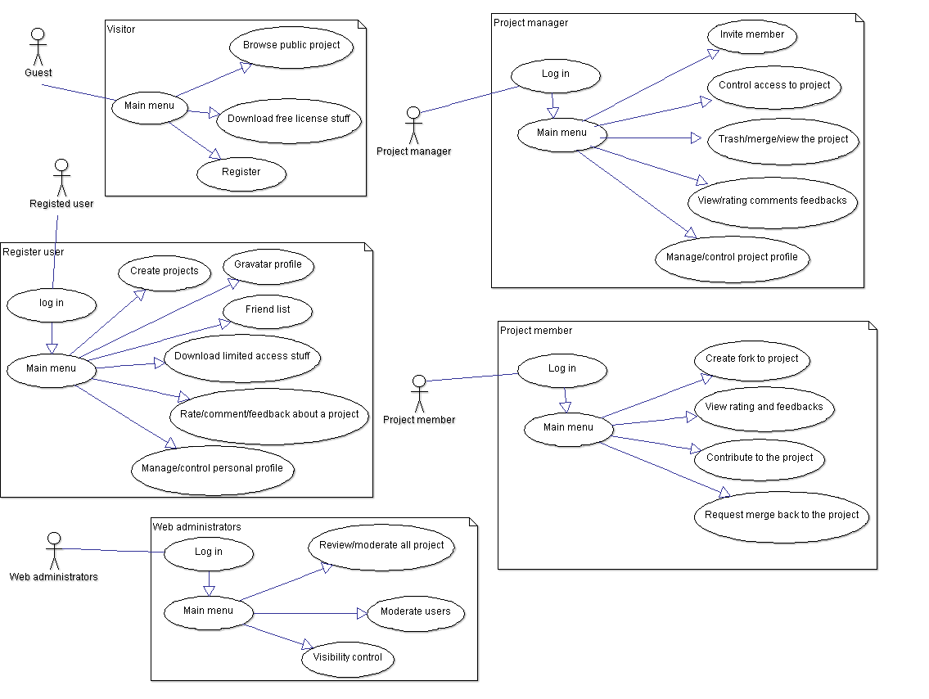

# Priority Queue for 'Collaboration Corner'

**Week 7:**

* Figure out a good layout for the website and get a basic version up and running.
* Users should be able to register a new account, login and edit their personal profile.
* Let users create mock projects.

**Week 8 & 9:**

* Get basic social networking going, i.e., users can add other users as friends etc.
* Let users create basic projects and browse projects from their friends.

**Week 10 & 11:**

* Let users create Project profiles for the projects they own.
* Add access control to projects.
* Let users fork projects they have access to.

**Week 12:**

* Add comments, ratings, versioning history etc. to the projects.

**Week 13:**

* Work on making the site look better with ajax.
* Add functionalities to existing features.

**Week 14:**

* Additional features if time permits.
* Potentially include some interesting project templates or WIP projects to kick-off the site.

**Week 15:**

* Iron out everything and have a working system.